**Building The Code**

First, install all of the prerequisites below.

**Prerequisites**

* Microsoft Visual Studio 2013

<http://go.microsoft.com/?linkid=9832270&clcid=0x409>

* Microsoft .NET Framework 4.5.1

<http://www.microsoft.com/en-us/download/details.aspx?id=40779>

* Microsoft DirectX SDK

<http://www.microsoft.com/en-us/download/details.aspx?id=6812>

* Visual Studio Installer Projects Add-In

<http://visualstudiogallery.msdn.microsoft.com/9abe329c-9bba-44a1-be59-0fbf6151054d/file/130817/3/VSI_bundle.exe>

* TortoiseSVN

<http://tortoisesvn.net/downloads.html>

Download all of the Lightning’s Tools source code by following these steps:

1. Create a folder on your hard drive to hold the code (recommend: **C:\code**)
2. Right-click on the folder and select SVN -> Check Out
3. In the dialog box that pops up, enter the following exactly as you see it below:

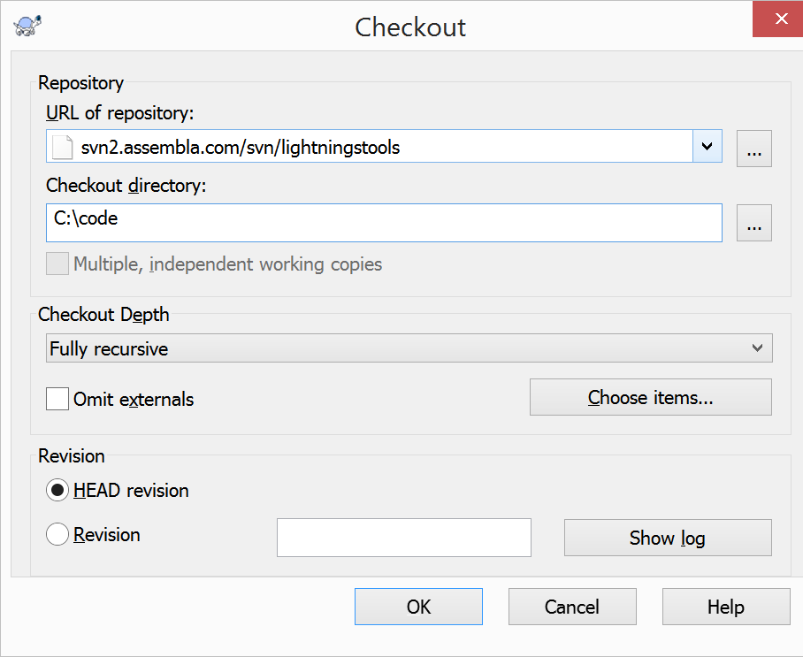

Click OK. This will download all of the code from the Lightning’s Tools and Utilities repository.

Next, launch Visual Studio 2013 from the Start Menu, and select **File->Open->Project/Solution**. Navigate to **C:\code\trunk\MasterBuild** and select **BuildAll.sln**

Ensure that the drop down menu to the right of the “Start” button on the toolbar says “Release”. If it says “Debug”, change it to “Release”.

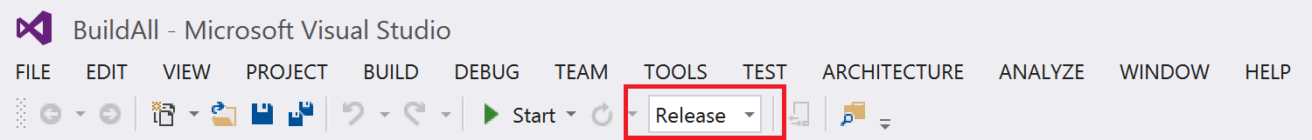

Next, From the **Build** menu, select **Build Solution**. This will compile all of the code and will build the installers for all projects that have an installer.

After building, the installers will be located in the following directories:

**MFD Extractor**C:\code\trunk\MFDExtractor\MFDExtractorSetup\Release

**CPD**C:\code\trunk\F16CPD\F16CpdSetup\Release